**Knee Cartilage Repair Rehabilitation Protocol**

By Patrick J. McGahan, MD

|  |  |  |  |
| --- | --- | --- | --- |
| Phase | Time | Exercises/Activities/RESTRICTIONS | Goals |
| Early Post operation | 0-2 weeks | **Non weight bearing**  **Brace in extension**  **CPM—advance a as tolerated**  Passive/Active ROM  Straight leg raise  Quadriceps isometrics  Patella mobilizations | Pain and swelling control |
| Phase I | 2-6 weeks | **Toe-touch weight bearing**  **Brace in extension**  **Continue CPM**  Patella mobilizations  Active/passive/AAROM  Straight leg raise, Quad isometrics  Hip resistive exercises  Plantar flexion theraband  Stationary bike with NO resistance  Modalities OK  Home exercise program | ROM to 120º  Healing of cartilage lesion |
| Phase II | 6-12 wks | **Discontinue brace/crutches**  **--transition to unloading brace**  **--discontinue crutches when gait has normalized**  **Discontinue CPM**  AAROM exercises  Leg press—0-60º arc  Mini-squats/wall slides  Proprioception/balance program  Hip/CORE program  Forward step-up program  Straight leg raise  Stair master/elliptical  Pool therapy OK  Modalities OK  Home exercise program | ROM to normal  Normal patellar mobility  Restore normal gait  Ascent stairs with good control |
| Phase III | 12-20 wks | **No Running**  Progress squat program  Initiate step-down program  Leg press, Proprioception training  Agility exercises, Elliptical  Lower extremity stretching  Modalities  Home exercise program | Descend stairs with good control  Return to normal ADL  Improve flexibility |
| Phase IV | ˃20 wks | Continue LE strengthening/flexibility  Forward running (per MD)  Brace for sports (per MD) | Sport specific activity  Running in 5-8 months |

**Post Operative Instructions**

**ON THE DAY OF SURGERY:**

**Ice**: Use ice or the cold therapy unit over the leg for 15 minutes every 1 to 2 hours to decrease pain and inflammation.

**Pain medication**: You will be given a prescription for a narcotic for pain control. Begin taking the pain medication as prescribed as soon as you have pain. Do not wait until you are in severe pain before taking them as it takes 30 to 45 minutes to work. You should be able to stop taking the pain medicine within two to three weeks. Avoid taking Tylenol while you are taking the narcotic as they both contain acetaminophen which can be dangerous to your liver in high amounts.

**Eating**: Begin eating with liquids and light foods (jello, soup, bread). Progress to your normal diet slowly over the 24 hours following surgery. The narcotics can make you nauseous, so take them with food whenever possible.

**DAY 1 AND UNTIL POST-OP VISIT:**

**Dressings**: Remove 3 days after surgery and replace with band aids.

**Walking: DO NOT PUT WEIGHT ON THE LEG.** Walk with your leg elevated off the ground and with your crutches.

**Bathing**: Ok to shower 3 days after surgery. Do not bathe in a tub for 3 weeks. Do not swim in a pool or the ocean until instructed by your surgeon.

**Crutches**: Continue to use the crutches until instructed by your doctor.

**Brace**: **DO NOT PUT WEIGHT ON THE LEG**. If you are given a brace, you may unlock it to perform your exercises, when in a motion machine, or sitting in a car or chair.

**CPM**: You may given a CPM for knee range of motion. Start at 0-30 degrees, and advance 5 degrees every 12 hours until you are at 90 degrees. Use it for 6 hours/day for 6 weeks.

**Driving**: Do not drive until instructed to do so.

**Therapy**: Contact a physical therapist prior to surgery to begin formal physical therapy approximately 5-10 days following your surgery.

It is normal to experience some swelling in the knee and leg. To decrease this, keep your le elevated above the level of your heart as much as possible.

Avoid putting a pillow behind your knee as this can cause problems getting your knee straight.

**Post Operative Instructions: Knee Surgery**

**EXERCISES: START POST-OPERATIVE DAY 1:**

1. **Straight Leg Raises**. Lift your leg about twenty-four (24) inches off the ground and hold it for 10 seconds. Do a minimum of three (3) sets of ten (10) repetitions. Make sure you do this with your brace locked in full extension.

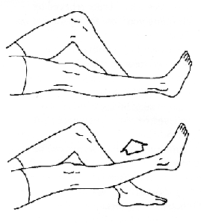

2. **Quad Sets**. With this exercise, you tighten you thigh muscles and hold for five (5) seconds. Do a minimum of three (3) sets of ten (10) repetitions. When you tighten your thigh muscles, it will feel like your knee is being pushed into the ground. Make sure you do this with your brace locked in full extension.

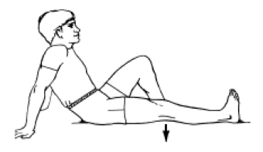

3. **Move your kneecap (patella) side to side**. Move the kneecap toward the inner side of your leg and hold it for five (5) seconds. Do three (3) sets of ten (10) repetitions in each direction. This will be harder to do until the bandages are removed.

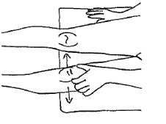

4. **Heel Slides**. (bending the knee) slide your heel toward your buttock. This may be assisted by using a towel to pull your foot.

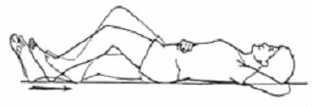

5. **Bridging Exercises**. Roll a towel and put it under your heel with nothing under your knee. Keep this position for 5 to 10 minutes. You can assist this by resting your hand on your thigh, near the knee.

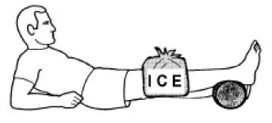

6. **Calf Pumps**. Move both ankles up and down, at least 10 times an hour until you are up and around regularly to encourage blood flow in the lower legs and reduce the risk of DVT (blood clot).

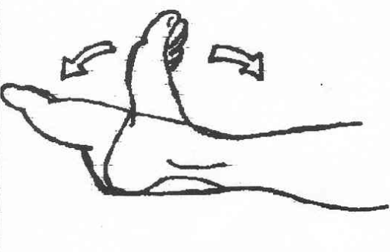

7. **CPM**. A CPM (continuous passive motion) machine may be ordered by your surgeon. This machine helps gain your motion a little faster than if you did not have it, and may help with stiffness. Use this machine at least six (6) hours a day (you may want to do this at night)- if so, you will probably need sleeping pills such a Benadryl to help you for the first few nights. Start at zero (0) to thirty (30) degrees, and increase it five (5) degrees every twelve (12) hours as tolerated. You may return the machine when your knee bends more than ninety (90) degrees with the therapist or the machine is at its full range zero (0) to one hundred twenty (120) degrees for two (2) to three (3) days. Unlock your brace to use the CPM (**do not remove the brace**).