**Knee Quadriceps & Patella Tendon Repair Protocol**

By Patrick J McGahan, MD

|  |  |  |  |
| --- | --- | --- | --- |
| Phase | Time | Exercises/Activities/RESTRICTIONS | Goals |
| Early Post operation | 0-2 weeks | Brace on at all times   * Keep locked in extension * Remove only for bathing   Weight Bearing in Extension  Avoid active knee extension | Pain and swelling control |
| Phase I | 2-6 weeks | Continue with brace   * Bear weight in extension   Avoid active knee extension and Avoid Aggressive flexion  Physical Therapy  Range of motion exercises  0-2 weeks= 0 to 50°  2-4 weeks= 0-75°  4-6 weeks= 0-90°  Active assisted extension  Quadriceps isometrics  Straight leg raise with brace at 0  Hip/CORE/ankle strengthening  Scar and Patella mobilizations  Modalities- stimulation OK | Tendon healing  Pain and swelling control  Range of motion 90° |
| Phase II | 6-12 wks | Brace unlocked to 60° with good quadriceps control   * Remove brace as tolerated   Avoid aggressive flexion Range of motion (ROM)  A/AAROM knee extension exercises  Continue patellar mobilization  Progression to regular bike  Leg press with ROM ˃ 60°  Initiate forward step-up program  Wall slides  Proprioception program  Modalities OK  Home Exercise program | Improve ROM to 120°  Improve quadriceps strength  Normalize gait  Discontinue brace/crutches |
| Phase III | 12-20 wks | Knee Flexion ROM  Quad/Hamstring strengthening   * Step up/step down * Progress squat program   Advanced proprioception  Agility training  Elliptical OK, Bike OK  Modalities and Home exercise program | Full knee ROM  Improve quadriceps flexibility  Return to normal ADL  Independent in home therapy |
| Phase IV | ˃20 wks | Continue lower extremity strengthening  Plyometric program  Running program  Agility/sport specific program  Home exercise program | Pain free running  Sport-specific activity |

**Post Operative Instructions**

**ON THE DAY OF SURGERY:**

**Ice**: Use ice or the cold therapy unit over the leg for 15 minutes every 1 to 2 hours to decrease pain and inflammation.

**Pain medication**: You will be given a prescription for a narcotic for pain control. Begin taking the pain medication as prescribed as soon as you have pain. Do not wait until you are in severe pain before taking them as it takes 30 to 45 minutes to work. You should be able to stop taking the pain medicine within two to three weeks. Avoid taking Tylenol while you are taking the narcotic as they both contain acetaminophen which can be dangerous to your liver in high amounts.

**Eating**: Begin eating with liquids and light foods (jello, soup, bread). Progress to your normal diet slowly over the 24 hours following surgery. The narcotics can make you nauseous, so take them with food whenever possible.

**DAY 1 AND UNTIL POST-OP VISIT:**

**Dressings**: Keep the dressing on the surgical site until your first post-operative visit— usually 10-14 days after your surgery. This decreases the risk of post-operative infection. Do not put ointment on your incisions.

**Bathing**: You may sponge bathe following the surgery. You can also shower with a plastic garbage bag around the leg, but you must keep the dressing absolutely dry. Do not bathe in a tub. Once the sutures are removed you may shower or bathe and get the incision wet. Do not swim in a pool or the ocean until instructed by your surgeon.

**Crutches**: Continue to use the crutches for 8 weeks or until instructed by your doctor.

**Driving**: Do not drive until instructed to do so.

**Therapy**: Contact a physical therapist prior to surgery to begin formal physical therapy ap-proximately 5-10 days following your surgery.

It is normal to experience some swelling in the knee and leg. To decrease this, keep your le elevated above the level of your heart as much as possible.

Avoid putting a pillow behind your knee as this can cause problems getting your knee straight.

**Post Operative Instructions: Knee Surgery**

**EXERCISES: START POST-OPERATIVE DAY 1:**

1. **Straight Leg Raises**. Lift your leg about twenty-four (24) inches off the ground and hold it for 10 seconds. Do a minimum of three (3) sets of ten (10) repetitions. Make sure you do this with your brace locked in full extension.

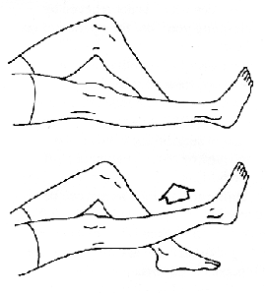

2. **Quad Sets**. With this exercise, you tighten you thigh muscles and hold for five (5) seconds. Do a minimum of three (3) sets of ten (10) repetitions. When you tighten your thigh muscles, it will feel like your knee is being pushed into the ground. Make sure you do this with your brace locked in full extension.

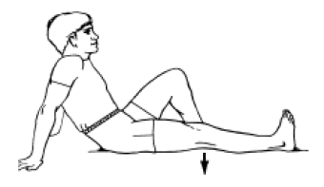

3. **Move your kneecap (patella) side to side**. Move the kneecap toward the inner side of your leg and hold it for five (5) seconds. Do three (3) sets of ten (10) repetitions in each direction. This will be harder to do until the bandages are removed.

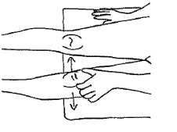

4. **Heel Slides**. (bending the knee) slide your heel toward your buttock. This may be assisted by using a towel to pull your foot. Do not go beyond the directed range of motion according to the week of the rehabilitation protocol.

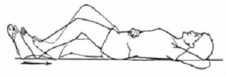

5. **Bridging Exercises**. Roll a towel and put it under your heel with nothing under your knee. Keep this position for 5 to 10 minutes. You can assist this by resting your hand on your thigh, near the knee.

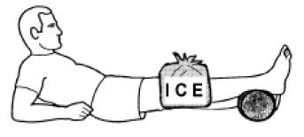

6. **Calf Pumps**. Move both ankles up and down, at least 10 times an hour until you are up and around regularly to encourage blood flow in the lower legs and reduce the risk of DVT (blood clot).

