**Knee PCL Reconstruction Rehabilitation Protocol**

By Patrick J McGahan, MD

|  |  |  |  |
| --- | --- | --- | --- |
| Phase | Time | Exercises/Activities/RESTRICTIONS | Goals |
| Early Post operation | 0-2 weeks | **Brace at all times, locked in extension**  **No Weight Bearing**  Passive/Active ROM  Straight leg raise  Quadriceps isometrics  Patella mobilizations | Pain and swelling control |
| Phase I | 2-6 weeks | **Brace/Crutches at all times**  **WB STATUS: up to 4 weeks NWB**  **RANGE OF MOTION: 0-90 degrees**  Patella mobilizations  Active/passive/AAROM  Straight leg raise  Quad isometrics  Hip/CORE/ankle strengthening  Modalities OK  Home exercise program | ROM to 90º  Healing of ACL/PCL Quadriceps control  Good patella mobility |
| Phase II | 6-12 wks | **D/C crutches when gait normalizes**  **Advance to full weight bearing**  **Unlock brace for gait/transition to small brace**  AAROM exercises  Leg press—0-90º arc  Step-up/Step-down  Lunges  Squats  Proprioception/balance program  Hip/CORE program  Straight leg raise  Stair master/elliptical  Modalities OK  Home exercise program | ROM to normal  Normal patellar mobility  Restore normal gait  Ascent stairs with good control |
| Phase III | 12-20 wks | Progress squat program  Advance quad/hamstring program  Proprioception training  Agility exercises  Elliptical  Lower extremity stretching  Modalities  Home exercise program | Descend stairs with good control  Improve flexibility  Running at 6 months |
| Phase IV | ˃20 wks | Continue LE strengthening/flexibility  Forward running (per MD)  Brace for sports (per MD) | Sport specific activity  Return to competitive activities at 10-12 months |

**Post Operative Instructions**

**ON THE DAY OF SURGERY:**

**Ice**: Use ice or the cold therapy unit over the leg for 15 minutes every 1 to 2 hours to decrease pain and inflammation.

**Pain medication**: You will be given a prescription for a narcotic for pain control. Begin taking the pain medication as prescribed as soon as you have pain. Do not wait until you are in severe pain before taking them as it takes 30 to 45 minutes to work. You should be able to stop taking the pain medicine within two to three weeks. Avoid taking Tylenol while you are taking the narcotic as they both contain acetaminophen which can be dangerous to your liver in high amounts.

**Eating**: Begin eating with liquids and light foods (jello, soup, bread). Progress to your normal diet slowly over the 24 hours following surgery. The narcotics can make you nauseous, so take them with food whenever possible.

**DAY 1 AND UNTIL POST-OP VISIT:**

**Dressings**: Remove Dressings in 3 days and replace with band-aids

**Bathing**: ok to shower in 3 days. Do not bathe in a tub. Do not swim in a pool or the ocean until instructed by your surgeon.

**Crutches**: Continue to use the crutches for approximately 4 weeks or until instructed by your doctor.

**Driving**: Do not drive until instructed to do so.

**Therapy**: Contact a physical therapist prior to surgery to begin formal physical therapy ap-proximately 5-10 days following your surgery.

It is normal to experience some swelling in the knee and leg. To decrease this, keep your le elevated above the level of your heart as much as possible.

Avoid putting a pillow behind your knee as this can cause problems getting your knee straight.

**Post Operative Instructions: Knee Surgery**

**EXERCISES: START POST-OPERATIVE DAY 1:**

1. **Straight Leg Raises**. Lift your leg about twenty-four (24) inches off the ground and hold it for 10 seconds. Do a minimum of three (3) sets of ten (10) repetitions. Make sure you do this with your brace locked in full extension.

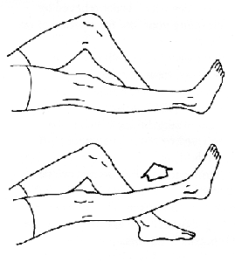

2. **Quad Sets**. With this exercise, you tighten you thigh muscles and hold for five (5) seconds. Do a minimum of three (3) sets of ten (10) repetitions. When you tighten your thigh muscles, it will feel like your knee is being pushed into the ground. Make sure you do this with your brace locked in full extension.

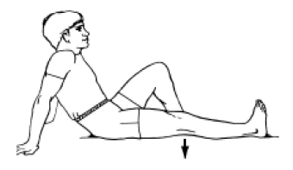

3. **Move your kneecap (patella) side to side**. Move the kneecap toward the inner side of your leg and hold it for five (5) seconds. Do three (3) sets of ten (10) repetitions in each direction. This will be harder to do until the bandages are removed.

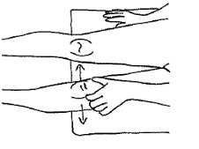

4. **Heel Slides**. (bending the knee) slide your heel toward your buttock. This may be assisted by using a towel to pull your foot.

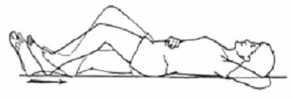

5. **Bridging Exercises**. Roll a towel and put it under your heel with nothing under your knee. Keep this position for 5 to 10 minutes. You can assist this by resting your hand on your thigh, near the knee.

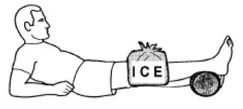

6. **Calf Pumps**. Move both ankles up and down, at least 10 times an hour until you are up and around regularly to encourage blood flow in the lower legs and reduce the risk of DVT (blood clot).

