**Shoulder Replacement Rehabilitation Protocol**

By Patrick J. McGahan, MD

|  |  |  |  |
| --- | --- | --- | --- |
| Phase | Time | Exercises/Activities/RESTRICTIONS | Goals |
| Early Post operation | 0-2 weeks | Rest, ice to affected shoulder  Continue sling at all times except for bathing  Physical Therapy  Passive forward flexion to 120°  Passive external rotation to 30°  Scapula isokinetics  Pendulum exercises  **Avoid active elevation of arm**  **Avoid lifting of objects in arm** | Pain and swelling control  Begin passive motion program |
| Phase I | 2-6 weeks | **Sling at all times except bathing** and **PT**  Subscapularis precautions: no active IR or aggressive ER stretches    Physical Therapy  Passive forward flexion to 120°  Passive external rotation to 30°  Scapula isokinetics  Pendulum exercises  **Avoid active elevation of arm**  **Avoid lifting of objects in arm** | Healing of  rotator cuff/ labrum  Restoration of passive ROM |
| Phase II | 6-12 wks | Discontinue sling    Physical Therapy Phase II  Modalities for pain control  Passive/Active ROM  Biceps/Triceps strengthening  Scapular stabilization program  Rotator cuff program when FF > 90° and abduction > 90°  Pulleys OK  Teach home program | Full ROM  Beginning active forward elevation, active IR, and rotator cuff strengthening program |
| Phase III | 12-20 wks | Continue with aggressive PT  Modalities for pain control  Passive/Active ROM  Biceps/Triceps strengthening  Scapular stabilization program  Rotator cuff program with weights  Pulleys OK  Pool therapy for ROM  Teach home program | Full ROM  Strength to 90% compared to other side |
| Phase IV | ˃ 20 wks | Advance to sport specific activities | Return to sport specific activities |

**Post Operative Instructions**

**ON THE DAY OF SURGERY:**

**Ice**: Use ice or the cold therapy unit over the shoulder for 15 minutes every 1 to 2 hours to decrease pain and inflammation.

**Pain medication**: You will be given a prescription for a narcotic for pain control. Begin taking the pain medication as prescribed as soon as you have pain. Do not wait until you are in severe pain before taking them as it takes 30 to 45 minutes to work. You should be able to stop taking the pain medicine within two to three weeks. Avoid taking Tylenol while you are taking the narcotic as they both contain acetaminophen which can be dangerous to your liver in high amounts.

**Eating**: Begin eating with liquids and light foods (jello, soup, bread). Progress to your normal diet slowly over the 24 hours following surgery. The narcotics can make you nauseous, so take them with food whenever possible.

**DAY 1 AND UNTIL POST-OP VISIT:**

**Dressings**: Keep the splint on the surgical site until your first post-operative visit— usually 10-14 days after your surgery. This decreases the risk of post-operative infection.

**Bathing**: You may bathe after your surgery, but keep the arm elevated and out of the tub, with the dressings completely dry and the bandages on. Do not shower as the dressing will get wet. Once the sutures are removed you may shower or bathe and get the incision wet. No swimming in the poor or ocean until instructed by your surgeon.

**Sling**: Continue to use the sling until your first post operative visit. You will continue to wear the sling for **6 weeks** following surgery to allow for time for the shoulder to heal.

**Driving**: Do not drive until instructed to do so.

**Therapy**: You will begin formal physical therapy at **7-10 days** following surgery. Contact a local physical therapy provider to begin therapy prior to surgery in order to schedule a physical therapy visit.

It is normal to experience some swelling and bruising in the arm, elbow, and wrist. You may bend the elbow and wrist. This will decrease the amount of swelling that you have in the arm. It is very helpful to keep the arm elevated on 2-3 pillows so that the arm is above the level of the heart while lying down.

**Post Operative Instructions: Shoulder Surgery**

**EXERCISES:**

**Do these exercises following your shoulder surgery to decrease your pain and swelling and increase your range of motion.**

**START POST-OPERATIVE DAY 1 (do 5 times a day):**

Begin range of motion exercises of the elbow, wrist, and hand immediately, as comfort permits. Straighten and bend the elbow, wrist, and fingers. Do these exercises several times a day so your elbow, wrist, and hand do not get stiff.

**Shoulder shrugs.** Shrug your shoulders up as far as they can go, and hold them there for a count of 5- 10 seconds. Lower your shoulders down and then repeat 10 times. See Figure 1

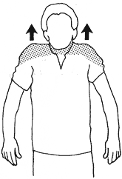

**Scapula Squeeze:** Flex the muscles between your shoulder blades and try and pull your shoulder blades together in the back. Hold your muscles in that position for 5-10 seconds. Relax and then repeat 10 times.

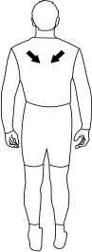

**Ball squeezes.** (Tennis ball or small squeezable ball)

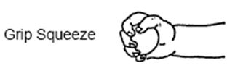

**Elbow Range of Motion:** Remove arm strap of sling. Straighten and bend your elbow as far as you can tolerate. Do this 10 times slowly.

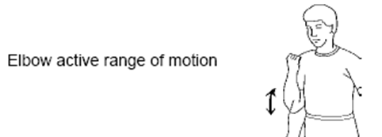

Actively turn your palm up, then down. Do this 10 times to work on hand and wrist rotation.

**Pendulum Exercises**: Remove sling and bend at waist to 90 degrees. Gently swing arm in circular “pendulum” motion

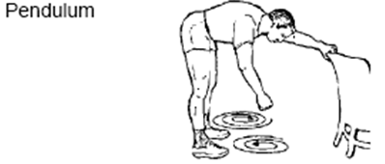

**Shoulder Range of Motion:** Remove arm strap of sling. Gently, **use your non operative arm to** lift your arm up; do not lift the elbow higher than your shoulder (90 degree elevation). Again this should be **passive motion** (you or someone else lifts the arm for you), **not active**. This will be difficult to do at first, but it will gradually get easier and easier.

**Ice with sling on:**

